PIZZA SALES SQL QUERIES

A year's worth of sales from a fictitious pizza place, including the date and time of each order and the pizzas, served, with additional details on the type, size, quantity, price, and ingredients.

**Recommended Analysis**

1. How many customers do we have each day? Are there any peak hours?
2. How many pizzas are typically in order? Do we have any bestsellers?
3. How much money did we make this year? Can we identify any seasonality in the sales?
4. Are there any pizzas we should take off the menu, or any promotions we could leverage?

**Dataset Link:**

<https://www.kaggle.com/datasets/mysarahmadbhat/pizza-place-sales>

# **How many customers do we have each day?**

SELECT

DATE(order_date) AS per_day,

COUNT(DISTINCT (order_id)) AS orders

FROM

pizzadb.pizza_sales

GROUP BY order_date;

RESULT :

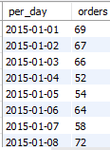

**# Are there any peak hours?**

SELECT

HOUR(order_time) AS peak_hour, COUNT(*) AS orders

FROM

pizzadb.pizza_sales

GROUP BY peak_hour

ORDER BY orders DESC;

RESULT :

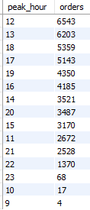

**# How many pizzas are typically in order?**

SELECT CAST(CAST(SUM(quantity) AS DECIMAL(10,2)) /

CAST(COUNT(DISTINCT order_id) AS DECIMAL(10,2)) AS DECIMAL(10,2))

AS Avg_Pizzas_per_order

FROM pizza_sales;

RESULT:



# Do we have any bestsellers?

SELECT

pizza_name, SUM(quantity) AS times_ordered

FROM

pizzadb.pizza_sales

GROUP BY pizza_name

ORDER BY times_ordered DESC;

RESULT:

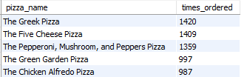

**# How much money did we make this year?**

SELECT

SUM(total_price) AS yearly_revenue

FROM

pizzadb.pizza_sales;

RESULT:



**#Can we identify any seasonality in the sales?**

SELECT

MONTHNAME(order_date) AS months, ROUND(SUM(total_price), 2) AS monthly_revenue

FROM

pizzadb.pizza_sales

GROUP BY months

ORDER BY monthly_revenue DESC;

RESULT:

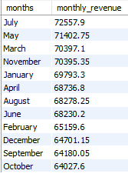

**# Are there any pizzas we should take off the menu,**

SELECT

pizza_name, SUM(quantity) AS sold

FROM

pizzadb.pizza_sales

GROUP BY pizza_name

ORDER BY sold ASC;

RESULT:

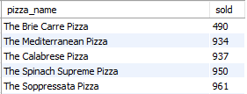

**#any promotions we could leverage?**

SELECT

pizza_category, ROUND(SUM(total_price), 2) AS total

FROM

pizzadb.pizza_sales

GROUP BY pizza_category

ORDER BY total DESC;

RESULT:

